Promotion

The main vehicle used to promote our surf shack is our web page

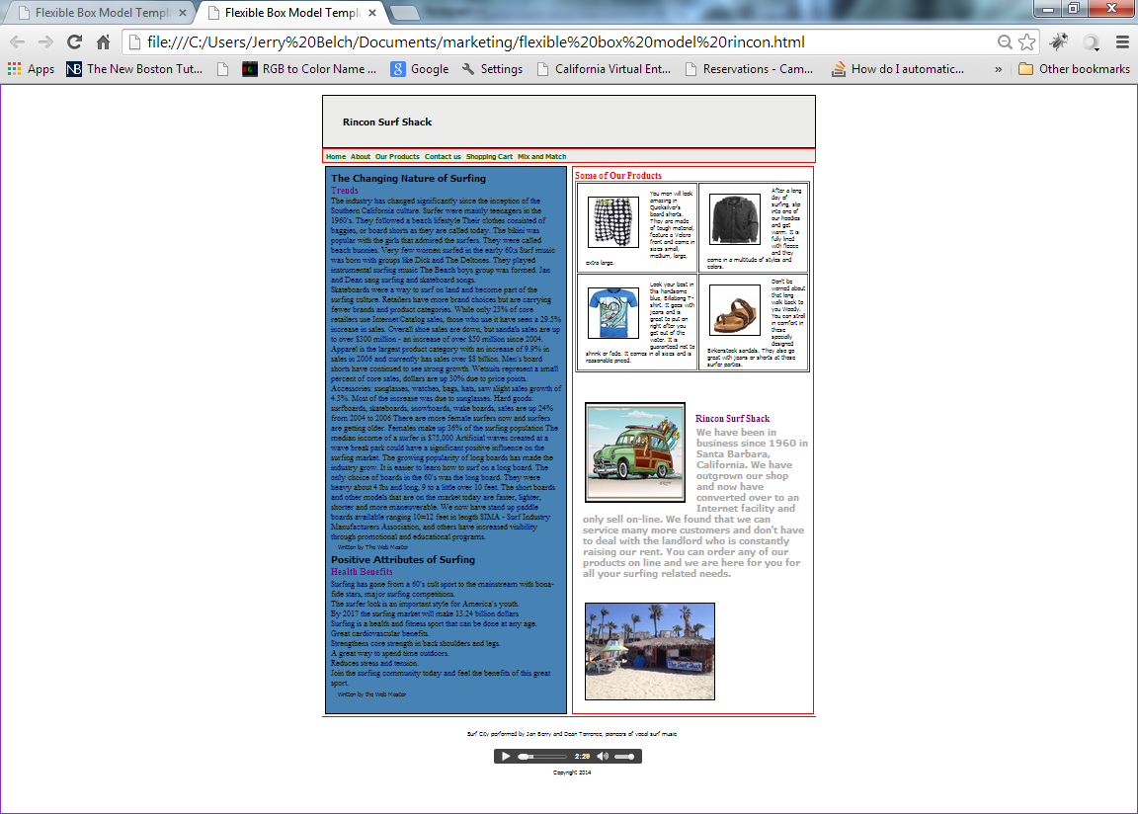
Our web page was coded in HTML 5 and represents the flexible box model of programming. HTML 5 makes it much easier to adapt web pages to other devices including cell phones and tablets.
It features two articles: one on the changing nature of surfing and the other on the health benefits of surfing. The right side of the screen id devoted to some of our product line including board shorts, T-shirts, hoodies and sandals. A picture of a vintage woody is shown along with our logo, which is a surf shack. The footer contains an audio player and allows the used to listen to Surf City, a number one hit on July 1963 by Jan Berry and Dean Torrance. The song was co-written by Jan Berry and Brian Wilson of Beach Boys fame.
Internet Advertisement
We designed and Internet ad to be included as an attachment to all Virtual Companies. I was coded in HTML 5 so that it can be viewed by cell phones, tablets as well as regular computers.
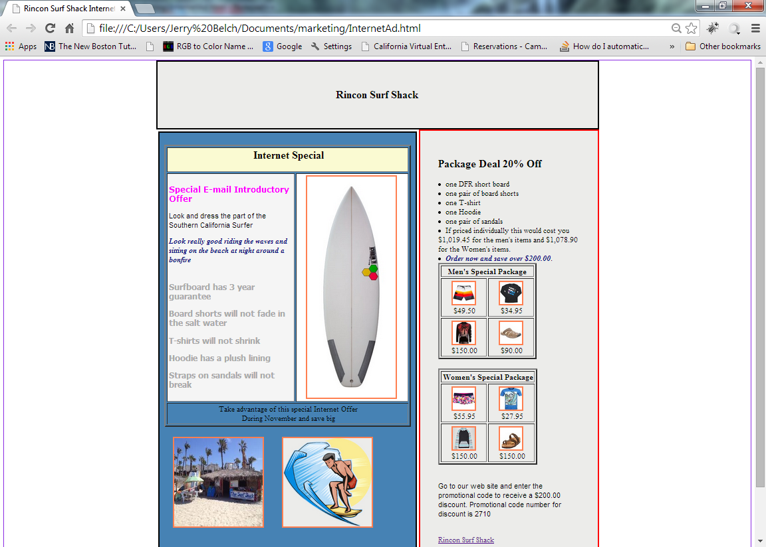
The ad offers a package deal on a surfboard, board shorts, a T-shirt, hoodie and sandals. There is a package for men and one for women. If they enter the correct promotional code on our web site they will receive 20% off of regular price.

Rincon Surf Shack
Booth 22
Trade Show Special – 25% off on these items
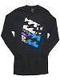  Billabong Tropics T-shirt $34.99 | 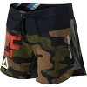  Women’s Camouflage Board Shorts  $39.99 | 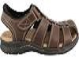  Dockers Marin Men’s Sandals  $44.95
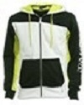  Tropics Hoodie  $100.00 | 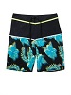  Men’s Surfer Safari Shorts  $75.00 | 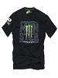  Hawaiian T-Shirt  $33.99

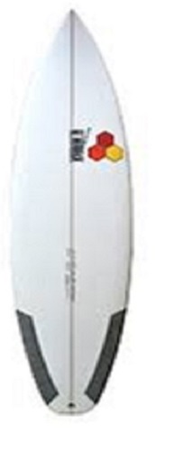DFR short board 5’6” - $680.00
Our flyer that will be used to promote our booth appears above and it features a 25% discount on the selected products.

We plan to hold a drawing for a T-shirt during each trade show.
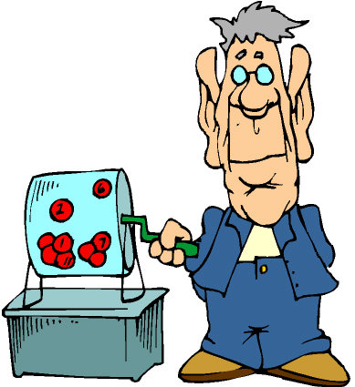

We plan to attend all of the California Trade Shows where our sales department can promote our products.

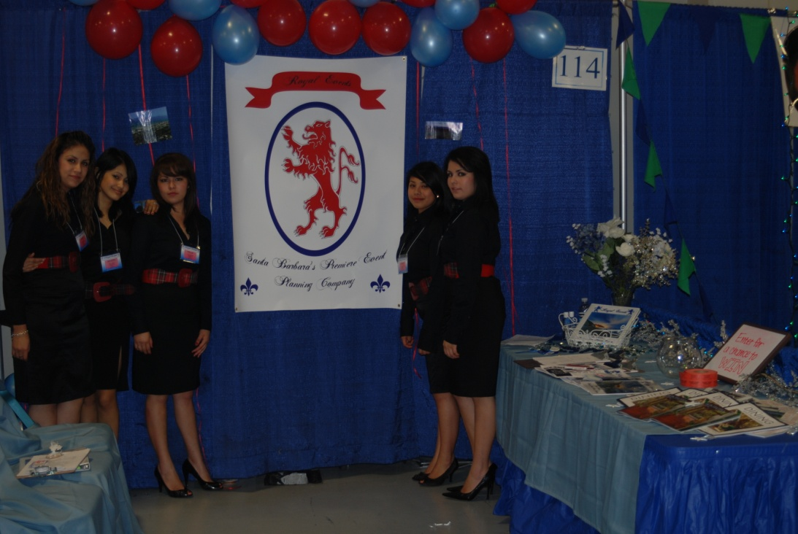

We will have a grand opening in January, where we will invite school personnel, city dignitaries. We plan to obtain TV coverage of the event and have a write up in our local newspaper.

