Cover Page

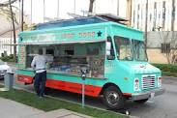
Inside Slider Food Truck and Catering Company
Serving all of Santa Barbara County

14100 Ridge Road

Santa Barbara, California 93888
(805) 555-1212

Email: InsideSliderCateringCompany@Gmail.com

Chief Executive Officer: Jerry Belch

Table of Contents Page

Cover Page | 1
Table of Contents | 2
Executive Summary | 3
Mission Statement | 4
Business Objective | 4
Company Description | 5
Description of Staffing | 5
Management Functions: Operating Procedures | 6
Goals and strategies | 7
Management Functions: Organizing | 8
Management Functions: Directing | 10
Management Functions: Controlling | 11
Marketing Plan Analysis | 11
Product/Service | 12
Placement | 13
Price | 14
Promotion | 16
Target Market | 17
Market Segments | 18
Initial Investment | 18
Business Loan/Balance Sheet | 20
Income Statement | 22
Projected Salary Expense and Payroll Taxes | 23
Other projected expenses | 25
Cost of Goods Sold | 26
Break-Even Analysis | 26
Projected Monthly Income | 27
Projected Yearly Income | 30
Financial Write-Up | 30
Start-Up Budget | 31
Strengths, Weaknesses, Opportunities, Threats | 31
Appendix | 32

Executive Summary

The purpose of this document is to secure a loan to start up a mobile food truck and catering service in the Tri-county area s: Santa Barbara, Ventura and San Luis Obispo counties. Initially we will focus on two fronts: a mobile food truck business at certain locations each day and catering events for companies: retirement parties, Christmas parties, birthday parties, and special events.
The population of Santa Barbara County is 424,000. The population of Ventura County is 823,000 and the population of San Luis Obispo County is 270,000. Since our market ranges in ages from children to senior citizens, we can consider almost all of these people as potential customers. Initially we will focus just on Santa Barbara County.
The employees of our company consist of the owner/CEO/food truck manager, food caterer/chef, a kitchen worker and window attendant.
The marketing mix consists of the following: Product: We will focus on sliders as our main product. They are easier to eat than traditional hamburgers. Customers can purchase one or more with fries and a drink. Place: We focus on the waterfront area of Santa Barbara as where to locate our truck each day. Santa Barbara is a tourist town and many people frequent the waterfront: Sterns Wharf, the harbor, East and West Beach and an area called the funk zone. Special events occur often in the area: cruise ships arrive every few weeks, there are major events: fiesta, beach volleyball tournaments, breast cancer walks Alzheimer’s walks, and other charity events. Our mobile food truck can be driven to each event. Promotion: We will promote our business by creating a web page with shopping cart, photo gallery, event cost estimator and comments from satisfied customers. We will also use social media to promote our business. Price We can offer competitive pricing over the restaurants in the area, since we do not have leases, utilities, property taxes, high overhead, and limited staffing.

Our financial projections show a break even at $26,961 per month. Our projected income for the first year looks like $47,033.55. The projection assumes a 2% increase in food truck sales each month. Projected income for each month is as follows:

January: $5294.75
February: $6,149.48
March: $6,527.08
April: $7,811.84
May : $5,625.61
June: $12,072.49

SWOT: our strength lies in our flexibility to deliver numerous products to anywhere in the county without paying for a venue or reception hall. Our weakness is that some people still view catering trucks as those that serve substandard food and lack cleanliness. Opportunity : We can easily expand into other markets without any other additional investments: constructions sites and parking lots of major corporations in the area. Threats: It is relatively easy with only a small investment to enter the market and create competition for us.

Mission Statement:

Our company's objective is provide high-quality food at a reasonable price, cooked and served at the event site. Our food truck's kitchen will be designed to accommodate the preparation of numerous food types: American, Chinese, Italian, and Mexican. In the beginning we will locate our truck in populated tourist places along the waterfront. We will also cater: birthdays, weddings, anniversaries, holiday parties ranging in size from 10 to 100 persons. Later we will expand our business to include additional trucks, catering at construction sites and parking lots of corporations and businesses in our area, as well as expanding into Ventura and San Luis Obispo counties.

Business Objectives

To obtain a loan for approximately $100,000, which will be used to purchase a food truck, inventory, and 5-month's worth of operating expenses and required permits and licenses.
We will initially sell our sliders at various tourist locations and cater special events at their site.
Expansion plans at a later date, will add catering at construction sites, and company parking lots for breakfasts and lunches.
We will also expand into neighboring counties and purchase additional trucks.
Another objective will focus on company sponsored events, like office parties, retirement parties, new product introduction events.
We will also direct our marketing efforts to the consumer side: birthdays, weddings, Bar Mitzvah, Quinceanera's, graduation parties.

Company Description

Inside Slides & Catering company is an S corporation located at 14100 Ridge Road in Santa Barbara California. The corporation was formed on January 1, 2017. The phone number is (805) 960-5555. Our web address is <A href="http://insidesliders.com">Inside Sliders.com. Our e-mail address is InsideSliders@gmail.com
The company is a mobile food truck catering company serving Santa Barbara, Ventura and San Luis Obispo California. Initially we will focus our efforts on street corner locations in the highly populated waterfront areas of Santa Barbara. We will also provide catering anything from a corporate formal dinner to kids' birthday parties. We cater to events from 10 to 100 people.

The tri-counties market of Santa Barbara, Ventura and Ventura County boast a total of about 45 food trucks. The information was obtained by using Yelp. I searched food trucks and the county name. Some of the listings were not mobile but brick and motor restaurants that did catering. Food choice were Mexican food: tacos and tamales, Asian food, hot dogs, burgers, Italian, Korean BBQ, a coffee truck, comfort food and even one French food truck.

The key personnel consist of the owner, food truck manager one full time caterer/cook and two caterers. The food truck manager is a full-time employee One caterer/cook is also full-time These two take the truck out each day to the waterfront during meal times. The caterers are part-time employees used just for the actual catering events.
The owner has business experience in sales and Bachelor’s of Science degree in Business Administration. Graduate courses include web page design and automated accounting. The food truck manager has extensive experience in the fast food industry and managerial experience in a number of restaurants in the area. The caterers all have graduated from the food services program at our community college and have at least 3 years experience in the catering business.

Description of Staffing
The owner, Jerry, and food truck manager, and one cater/cook are full time employees. The owner does all of the accounting, marketing, web page design, human resources duties. Bob orders the food for each event, maintains the truck's inventory of staple items, plans the actual event, coordinates the personnel needed and assists the employees at the events that are catered.

The organization chart for our company appears below.
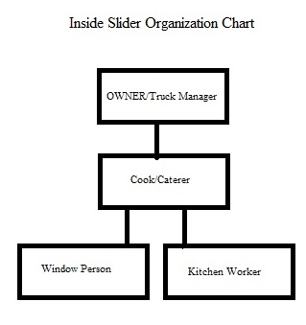
The duties and salaries of each employee in our organization appear in the table below
Job Title | Salary | Duties
CEO | $65,000 | Marketing, Accounting IT, Food Truck Manager
Cook/Caterer | $38,400 | Buy, prepare food, move to location, serve food
Window Person | $20,000 | Wait on customers, prepare sales slip, deliver food
Kitchen Person | $18,000 | Prepare and cut ingredients, clean up

Operating Procedures: Management Functions

The home base for the Inside Sliders Catering Company is 14100 Ridge Road, Santa Barbara California. It is a residence with a two car garage equipped with refrigeration, freezer and warehouse space for non-perishable food items. The office is a converted bedroom with computer with Internet access, file cabinet, book shelves and desks. The truck is 14.6 feet long by 7.6 feet wide. A blueprint of the layout appears below

- Generator
- Food Preparation area
- Flat grill
- Fryer
- Stove
- Refrigerator
- Freezer
- 30 gallon waste water tank
- 42 gallon fresh water tank
- Steel countertop with cabinets below
- Two liquid propane tanks
- Three bay sink

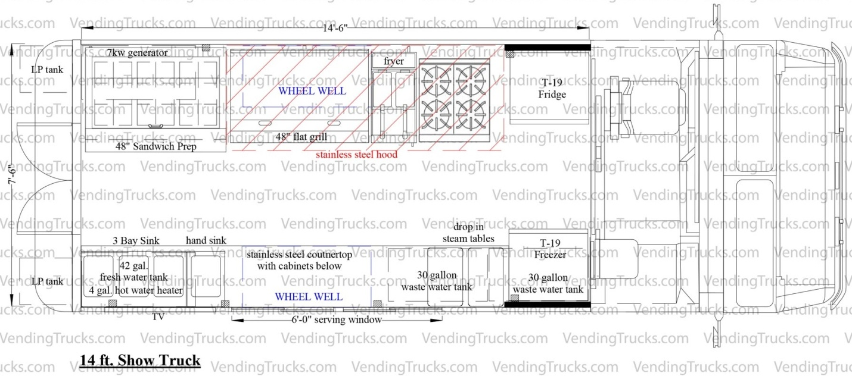
The advantage of our location is it mobility. We are located in Santa Barbara County. San Luis Obispo county is to the North and Ventura county is to the South. We are only about an hour's drive away from any possible catering event.
Possible expansion plans include adding more trucks, servicing construction sites, company parking lots for breakfast and lunch items and expanding into neighboring counties.

We will acquire our food supplies from a number of local vendors: Tri-County Produce, Jordano’s and Smart and Final. Our food truck manager will purchase and pick up these items as needed each day and for each event and store them in our garage/warehouse prior to the event. The truck will be stocked daily. and if a catering event, the day of the event, the food truck manager will stock the food truck with the needed items to prepare for the upcoming event.

Goals and Strategies

The goals of our venture are to make enough income to pay for salaries of all employees and the owner, to have enough funds to cover cost of goods sold, to have enough funds to pay our loan each month ,and to make a modest profit the first year.

We will accomplish these goals by preparing a break-even analysis, projecting income for the first three months and to schedule as many events as we can.

Organizing: meeting objectives
The major responsibility for the success of the organization falls on the CEO/Owner. In addition the Food Truck Manager will assume some major responsibilities as to the day to day operations.

The CEO/CFO/Marketing VP/IT Specialist will take on the responsibilities of the CFO, Marketing and Information technology roles.

CEO Responsibilities
- Oversee the entire operation: Financial, Marketing, Technology, Food Preparation
- Make hiring and firing decisions

CFO Responsibilities
- Prepare a break-even analysis
- Prepare financial projections for the first months of operation
- Do a cash flow analysis for the beginning months of operation.
- Pay all bills
- Make the loan payment
- Maintain checking account
- Prepare bank reconciliations
- Prepare the payroll
- Maintain all payroll records and pay the payroll taxes each quarter
- Journalize, post and take a trial balance each month
- Prepare income statement and balance sheet each month
- Advise company as to the profitability of the company

Marketing Responsibilities
- Do marketing research
- Evaluate competition
- Do a SWOT analysis
- Design the marketing plan including product, price and promotion
- Design invoice format for the company
- Produce a sales brochure
- Contact potential clients to schedule events
- Prepare Internet advertisements in conjunction with IT for our company
Information Technology Responsibilities
- Obtain Domain registration for company web site
- Find Web host for company
- Set up cloud computing using Drop Box
- Design responsive web site using media queries and flexible box model to accommodate mobile devices
- Tally responses to shopping cart for events and food choices and forward to Marketing Department

Food Truck Manager Responsibilities:
- Oversee the day-to-day operations at food truck and commercial kitchen.
- Plan for and purchase food for daily operations.
- Maintain required records including food production, inventory, income/expense, meal counts and personnel records.
- Ensure food truck staff members follow proper sanitation procedures.
- Preside over food truck employees, including cooks, food preparers, cashiers, and other employees.
- Ensure safety standards are maintained while food is being cooked.
- Prepare and serve the food.
- Plan menus.
- Respond to customer preferences and complaints.
- Set prices for each product on menu.
- Plan and budget for future meals.
- Maintain equipment including refrigerator, stove, prep table and cookware.
- Ensure customer dining experience is satisfactory.
- Expedite food preparation.
- Hire, recruit, and train employees.
- Deliver orders to appropriate customers.
- Direct the cleaning of the truck and commercial kitchen.
- Maintain employee records, prepare payroll, and complete paperwork to comply with laws and regulations.
- Keep records of supplies and purchases.

Caterers/Cook Responsibilities
- In charge of creating new and innovative dishes for celebrations or events
- Knowing what will be possible to cook all at once.
- Knowledge of ingredients and how to use them in a creative way
- Work with knives and must have excellent technique when cutting and preparing food.
- Serving delicious food
- Make sure each piece of food is safe, prepared correctly and tasty.
- Balance expenses with your profits,
- Manage the kitchen staff, minimize waste, and keep the kitchen running smoothly.
Food Truck Service Window Attendants
- Take customers' orders
- Serve food and beverages
- Prepare itemized checks
- Accept payments
- Must be familiar with the menu
- Know the daily specials
- May also work as a cook
Food Truck Kitchen Workers
- Measure ingredients
- Stir and strain soups and sauces
- Clean, peel and slice vegetables
- Cut and grind meats
- Unload truck each day
How is workflow disseminated?
The CEO/Owner determines the weekly locations of the truck, schedules the event, sets the prices for the event and notifies the food truck manager of the time, location and menu decided upon by the client.
Each week, the food truck manager goes to the wholesaler to purchase items necessary for the week. For catering events, the food truck manager goes to the food wholesaler to purchase the necessary items for the event. Truck is serviced and gassed up. All equipment is checked to make sure that it is in working order.
Prior to leaving each day or for an event, the truck is stocked with all necessary ingredients for the menu items to be catered or sold. The food truck manager takes charge of this important task. Based on the size of the event, the food truck manager assembles his staff of caterers and notifies them of location for the day or where the event will take place and the time frame including start time, setup time serving times and cleanup. The food truck manager, drives the truck to the location or event. After arrival, for event catering, they will notify the client that they have arrived and seek direction as to serving time.
Prior to the beginning serving time at each location, the cooking and food preparation will begin.
For event catering, the caterers will cook the food and serve it and at the end of the event clear up the dishes and the tables. The food truck manager will oversee this operation and in most cases help with the caterers duties. When the event or day is completed, the food truck manager will return the truck and clean all equipment and refrigerate of stock any left-over food items. A report will be given to the CEO as to the success of the operation.
Controlling - Keeping employees on track.
Prior to arriving at the daily locations or catering event, a time-line should be prepared as to the setup of the event, the cooking, serving and cleanup. It is the responsibility of the food truck manager to keep all tasks on target. Participation in future catering jobs or daily food truck operations will be contingent upon the individual performances of each cook or caterer.
Each caterer will be assigned one part of the operation, like setup, cooking, serving and cleanup.

Market Analysis
In the Santa Barbara, Ventura and San Luis Obispo counties there are approximately 40 food trucks: 17 in Santa Barbara County, 17 in Ventura county, and 7 in San Luis Obispo county. I used <u>Yelp</u> to find the competitors. Many of the food trucks serve up burgers, hot dogs and tacos. There are a few that have coffee, Asian, Italian, sushi, and BBQ items. There is even one French food specialist. The mobile food truck industry is showing consistent growth.

There is still plenty of room for growth. Many cities are trying to figure out how to regulate the food truck industry. Most cities are favorable to ordinances that will allow the food truck industry to expand and be successful. The average cost of a truck is $85,000, $90,000 for initial start up. Here is the breakdown by where the trucks are located: fifty five percent are on street corner, eighteen percent at special events, fifteen percent at construction and industrial sites and twelve percent at shopping malls.
One of the strengths of the industry is its portability. The truck can be moved to many locations quite easily compared to a restaurant. Another strength relates to the cost. A completely equipped food truck costs around $85,000, which includes all the equipment necessary to cook and store the menu items.
One of the biggest drawbacks relates to the past. Many mobile food trucks had the reputation of not being clean - roach coaches, and the low quality of the food. These past threats to the industry have improved over time due to festivals, where a number of food truck vendors are invited and competition between them.

Product/Service
Our product line consists of Sliders: beef, pork and chicken. We will also serve soft drinks, French fries, onion rings, baked beans and coleslaw.
To interest our customers in our products, we will feature pictures of the items on an electronic menu board attached to the outside of the truck. It will include images and prices of the items we have to offer for sale.
For our catering business we will have a web page and list our enterprise in Yelp, have a Facebook page, an Instagram and a Twitter accounts. We will offer monetary incentives if the "Like" us on the social media sites.

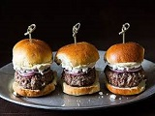  Classic Cheese  Portabella Mushrooms  Blue Cheese | French Fires
Onion Rings | 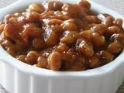  Baked Beans
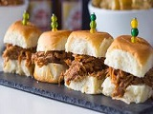  Pork Sliders | 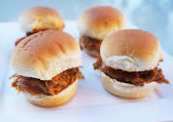  Chicken Sliders
Soft Drinks | 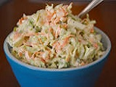  Coleslaw

Placement
Our company's channels of distribution begin with the producer-the farmer or rancher that produce the meat and vegetables. They sell their products to wholesalers like Smart and Final and Tri-county Produce Company. We buy our buns from local bakeries to ensure freshness each day. Inside Sliders is the retailer and we purchase items needed directly from the wholesalers. The consumers are the last loop of the channel of distribution. They buy their meals directly from us at our food truck locations or catered events. Our channels of distribution are shown in example 1 of the chart below.
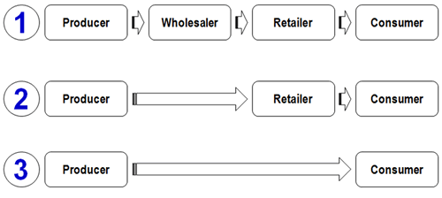

Price
Our main product is sliders. There are no other food trucks in our area that specialize in sliders. The closest competitor charges the following prices for its food items.

- Hamburger-Single Patty-$8.50
- Hamburger-Double Patty- $10.50
- Cheeseburger-Single Patty-$9.00
- Cheeseburger-Double Patty-$11.00
- Onion Rings-$4.50
- French Fries-$3.50
- Drinks-$1.50
Most restaurants and mobile food trucks use target-food-cost percentages to determine the retail price of the item. For example a cheeseburger who's food costs are $1.50 should sell for ($1.50/.35 = $4.30). The percentage varies. We used 35% which is at the high end of the percentage scale since the sliders are quite labor intensive. Taco and hot dog trucks typically use 20% to 25% as their percentages
Inside Slider's Ingredients Price List
Item Name | Meat Cost | Bun Cost | Other Ingredients | Total Cost
Beef Slider | $.60 | $.75 | $1.00 | $2.35
Pulled Pork Slider | $.32 | $.75 | $1.00 | $2.07
Jerk Chicken Slider | $.55 | $.75 | $1.00 | $2.30

Other ingredients include salt, pepper, mayo, ketchup, mustard, tomatoes, cinnamon, all spice, vegetable oil, lemon juice, molasses, orange juice, soy sauce, garlic, scallions, garlic powder, cayenne powder, celery salt, mustard powder
Toppings are also included here and they include, cheese, mushrooms, grilled onions.
Labor and Ingredients
Item Name | Target Food Cost | Ingredients Cost | Retail Price
Beef Slider | 35% | $2.35 | $6.71
Pork Slider | 35% | $2.07 | $5.95
Chicken Slider | 35% | $2.30 | $6.57

Other Menu Items
tem Name | Cost | Food Cost Percent | Actual | Retail Price
Onion Rings | $1.50 | 35% | $4.28 | $4.50
French Fries | $1.50 | 35% | $3.42 | $3.50
Soft Drinks | $.75 | 35% | $2.00 | $2.00
Coleslaw | $.75 | 35% | $2.00 | $2.00
Baked Beans | $.75 | 35% | $2.00 | $2.00

Profitability
Item Name | Cost | Retail | % Profit
Beef Sliders | $2.35 | $6.75 | 34.8%
Pork Sliders | $2.07 | $5.95 | 34.7%
Chicken Sliders | $2.30 | $6.65 | 34.5%
Onion Rings | $1.50 | $4.50 | 33.3%
French Fries | $1.20 | $3.50 | 34.2%
Soft Drinks | $.75 | $2.00 | 37.5%
Coleslaw | $.75 | $2.00 | 37.5%
Baked Beans | $.75 | $2.00 | 37.5%

Sales Tax Rates Santa Barbara County
City | Rate
Goleta | 7.75%
Gaviota | 8.5%
Guadalupe | 7.75%
Santa Maria | 7.75%
Carpinteria | 7.50%
Buellton | 7.50%
Casmalia | 7.50%
Cuyama | 7.50%
Isla Vista | 7.5%
Lompoc | 7.50%
Los Alamos | 7.50%
Los Olivos | 7.50%
Montecito | 7.50%
Orcut | 7.50%
Santa Ynez | 7.50%
Sisqouc | 7.50%
Solvang | 7.50%
Summerland | 7.50%
Vandenburg | 7.50%

Since all of our locations currently are projected for Santa Barbara, the tax rate that needs to be collected is 7.50%
Catering Prices
Our truck caters parties(Birthdays, weddings, graduation, holiday parties, anniversaries) and cooks the food at the event.
- The cost for the truck is $150.00 per hour
- There is a $200 non-refundable deposit to secure the event.
- The deposit will be applied to the truck rental time and or the items purchased.
- Our food items and prices are the same as food truck location prices as listed above.

Promotion
We will promote Inside Slider with the following methods.

- We will have a web site, <A href="insideSlider.html">Inside Slider</a>&nbsp; promoting our business, offering customers the opportunity to order food ahead of time to pick up at our truck.
- The site will feature a mechanism to allow customers to calculate the cost of our company catering the event for them.
- The site will also provide links to our Facebook, Twitter and Instagram sites.
- We will contact party equipment , rental companies and persuade them to make a link to our site.
- We will also provide a link to their company on our site.

- We will have our business listed in Yelp
- We will create banner ads that we will sell to wedding planners and party planners.
- We will feature direct e-mail ads to be sent to local businesses advertising our catering services for their company parties.
- We will also direct our efforts to secure their location for our food truck for lunches for their employees.
- We will set up a booth at all local wedding faires and home shows.
- We will design and leave flyers at local water-front businesses and party-equipment, rental businesses promoting our services.
- We will paint our truck with the company name, phone number and catering information.
- Social media promotions will include FaceBook, Instagram and Twitter.

Target Market
Our target market is complicated since we ,in effect, have two businesses: the food truck regular sales and a catering business.
The regular food truck business target market is as follows.
- Tourists and shoppers. Both groups frequent the area where our food truck will be located. That is where tour busses and cruise ships leave off their passengers to shop, go on tours and visit shops and attractions in the waterfront or shopping mall located just north of the pier.
- The tourist segment is quite affluent and has above average incomes.
- Hotel rates are quite high and have weekend minimum stays.
- The tourist are on vacation or have just exited one fo the many cruise ships that frequent our port monthly.
- Education level is probably not pertinent, although we will focus on customers with a high school education and maybe some college.
- A segment of the shoppers should include students, since they frequent the shopping areas adjacent to the waterfront. Many high-school and college-age shoppers are regular consumers of fast food.
- Many of our customers are quite computer literate and like to shop on-line. We should provide a way to order our sliders from their phones or tablets.
- We should also be prominent on social media, since most teenager and young adults are very active users.
Tourists also use the Internet to find attractions and things of interest while visiting Santa Barbara.

Market Segmentation

Our catering market segment is somewhat different from our regular food truck sales market. The catering division can be further segmented by looking at corporate catering events like company parties, grand openings, holiday parties, etc. Our consumer segment of the catering business will focus on birthday parties, weddings, graduations, etc.
Initial investment
- One of the most important parts of preparing a business plan is to determine what assets are needed.
- According to research previously done the following information is available
- An average food truck costs about $85,000
- Initial product inventory about $1,500
- Permits and licenses about $300
- Website about $100
- Cash Register/Point of sale about $500
- Uniforms about $500
- paper products about $250
- Miscellaneous assets about $500
- Pots, Pans Utensils about $1,500
- Fire Extinguisher about $150Total start up costs $90,300

The owner will invest $10,000, which will account for the cash on hand and our common stock. The rest of the money will be obtained from a loan. We will need to borrow 90,300 from the bank which is our Note Payable
Inside Slider Food Truck and Catering Company
Balance Sheet
Current Date
ASSETS
Cash 10,000.00
Food Truck 85,000.00
Acc. Depreciation Food Truck 0.00
Uniforms 500.00
Furniture and Fixtures 1,650.00
Acc. Depreciation Furniture 0.00
Paper Supplies 250.00
Permits & Licenses 300.00
Office Equipment 500.00
Acc. Dep. Office Equipment 0.00
Prepaid Insurance 0.00
Inventory 1,500.00
Other Assets 600.00
Total Assets 100,300.00

LIABILITIES
Notes Payable 90,300.00
Accounts Payable
Workers' Comp Payable
Federal Income Tax Payable
FICA Tax Payable
Medicare Tax Payable
Federal Unemployment Tax Payable
State Unemployment Tax Payable
Sales Tax Payable
SDI Tax Payable
State Income Tax Payable
State Employment Training Tax
Total Liabilities 90,300.00
STOCKHOLDERS' EQUITY

Common Stock 10,000.00
Retained Earnings
Total Liabil & Stock. Equity 100,300.00
Our total assets should equal our total liabilities plus stockholders equity (100,300 = 90,300 + 10,000)

The Business Loan
For the food truck and catering company, we need to borrow $90,300. We plan to pay it back in seven years at seven percent interest. We need to calculate the monthly payments and see how much of the payment goes to pay off the principal amount and how much is interest. If you search on line you can find a number of loan amortization calculators. I found one that use Excel. The link is below:
Loan amortization calculator
I have already filled in the amounts for our catering business loan. As you can see the payment amount is the same each month - $1.362.87 but the amount applied toward paying off the principal varies each month as does the interest part of the payment.
Month | Monthly Payment | Principal | Interest
1 | $1,362.86 | $836.12 | $526.75
2 | $1,362.86 | $841.00 | $521.97
3 | $1,362.86 | $845.90 | $516.97

Our completed balance sheet reflects the loan in the Note Payable Account.
Inside Slider Food Truck and Catering Company
Balance Sheet
Current Date
ASSETS
Cash 10,000.00
Food Truck 85,000.00
Acc. Depreciation Food Truck 0.00
Uniforms 500.00
Furniture and Fixtures 1,650.00
Acc. Depreciation Furniture 0.00
Paper Supplies 250.00
Permits & Licenses 300.00
Office Equipment 500.00
Acc. Dep. Office Equipment 0.00
Prepaid Insurance 0.00
Inventory 1,500.00
Other Assets 600.00
Total Assets 100,300.00

LIABILITIES
Notes Payable 90,300.00
Accounts Payable
Workers' Comp Payable
Federal Income Tax Payable
FICA Tax Payable
Medicare Tax Payable
Federal Unemployment Tax Payable
State Unemployment Tax Payable
Sales Tax Payable
SDI Tax Payable
State Income Tax Payable
State Employment Training Tax
Total Liabilities 90,300.00
STOCKHOLDERS' EQUITY

Common Stock 10,000.00
Retained Earnings
Total Liabil & Stock. Equity 100,300.00

Our total assets should equal our total liabilities plus stockholders equity (100,300 = 90,300 + 10,000)

Inside Slider Income Statement
The income statement show sales of our sliders and other menu items as well as cost of goods sold section and a section detailing all of the expenses needed to sell our product. We will use the income statement that shows the sale of merchandise. Our merchandise is composed of all of the ingredients necessary to make our menu items. It includes, ground beef, pork, chicken, buns, baked beans, onions, etc. A sample of our income statement is shown below. Currently there are no numbers in the statement. We explain each expense.

Inside Slider Food Truck and Catering Company
Income Statement
For the period ending Current Date
REVENUE
Sales
Other Income
Total Revenue
COST OF MERCHANDISE SOLD
Beginning Inventory
Purchases
Total cost of merchandise available for sale
Less: Ending Inventory
Cost of Goods Sold
Gross Profit

EXPENSES
Salary Expense
Repairs Expense
Advertising Expense
Supplies Expense
Depreciation Expense
Insurance Expense
Miscellaneous Expense
Payroll Taxes Expense>
Legal and Accounting
Utilities Expense
Web/Internet Expenses
Interest Expense
Delivery Expense
Total Expenses
Net Profit

Projected Salary Expense and Payroll Taxes Expense
The payroll information for the Inside Slider Company.
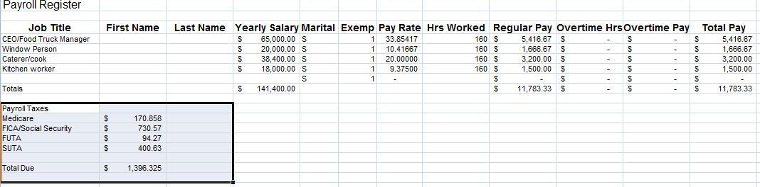

Examining the numbers show what the salary projections are for this company. A projected income statement must be submitted as part of the business plan proposal.

Job Title | Yearly Pay | Pay Rate | Hours Worked | Monthly Pay
Owner/Truck Mgr | $65,000 | $33.85 | 160 | $5,416.67
Window Person | $20,000 | $10.41 | 160 | $1,666.67
Caterer/Cook | $38,400 | $20.00 | 160 | $3,200
Kitchen Worker | $18,400 | $9.35 | 160 | $1,500

The total monthly salary expense is $11,783
The table below shows the payroll taxes for Inside Slider for this month. These taxes must be paid on a regular basis to the IRS and Franchise Tax Boards.
Tax | Percent | Amount
FICA/Social Security | .062 | $730.57
Medicare | .0145 | $170.85
FUTA | .008 | $94.27
SUTA | .034 | $400.63
Total | .1185 | $1,396.33

Look at the projected income statement below to see the placement of these amounts relating to salary.

Inside Slider Food Truck and Catering Company
Income Statement
For the period ending Current Date
REVENUE
Sales 00.00
Catering Income 00.00
Total Revenue 00.00
COST OF MERCHANDISE SOLD
Beginning Inventory
Purchases
Total cost of merchandise available for sale
Less: Ending Inventory
Cost of Goods Sold
Gross Profit

EXPENSES
Salary Expense $11,783.00
Repairs Expense $1,000.00
Advertising Expense $100.00
Fuel Expense $500.00
Depreciation Expense $762.49
Insurance Expense $300.00
Miscellaneous Expense $100.00
Payroll Taxes Expense $1,396.33
Legal And Accounting $00.00
Utilities Expense $100.00
Web Internet Expenses $20.00
Interest Expense $526.75
Propane Expense $100.00
Total Expenses $16,688.57
Net Profit

Other Projected Expenses
We need to project other expenses at this time. How much propane will we use? gasoline for the generator? Insurance for the food truck, gas and oil and maintenance on the truck, equipment repairs? amount spent on advertising? You will need to do some research on these expenses. In some cases you will find that these expenses are listed as a percentage of sales. We do not know this amount yet, so you might have to come back and do this a little later. Some of these expenses are listed on the income statement above

- Repairs expense: $1,000
- Propane/supplies expense: $100
- Insurance expense: $300
- Misc. expense: $100
- Phone: 100
- Website expense: $20
- Fuel expense: $500
- Interest on Loan :$526.75
- Depreciation expense: $762.49

Depreciation expense is a way of expensing out the cost of assets and goes toward reducing your taxable income. The truck costs 85,000. Depreciated over 10 years at a straight line method and divided by 12 equal amounts equals 708.33 per month. Furniture and fixtures are valued at $1,650 depreciated over 3 years = $550 per year or $45.83 per month. The office equipment depreciated in a straight line method over 3 years equals $8.33 per month. Therefore the total depreciation for our business is $762.49 per month

Cost of Goods Sold
The cost of goods sold for retail establishments selling food and beverages is about 74% according to BizStats.com. It ranges from 50%-75% food and labor to prepare the items. The food truck industry is a little different as far as cost of goods sold is concerned. It is somewhat less than the brick and mortar restaurants. There are no property taxes, rent, dishes to wash, tables to clear, customers to seat, and other expenses associated with the traditional restaurant. According to my research cost of goods sold or cost of sales is about 35%. This number is confirmed looking at the markup on each item on our menu. The 35% also includes the amount of labor needed to prepare our food.
Break Even Analysis
Our breakeven point calculated using the formula appears below. Simply put, subtract your cost of sales percentage from 100%. Then divide your fixed expenses by this number. This number is your break even sales number. We also need to see how many individual sales this represents.
Break Even = total fixed expenses/((100-total variable percentage/100))
Break even = 17,525/((100-35/100))
Break even = 17,525/.65
Break even = 26,961.54
Our income statement does not include the $836 payment on the principal of the debt. This accounts for the difference between $17,525 on the break even analysis and $16,688.57 total expenses on the income statement.

We calculated from doing research that an average food truck sale equals $12.40. If we divide our $26,961 by $12.40 we come up with 2,174 sales per month. We are open 22 days per month so we can calculate that we need about 98 sales each day to break even.
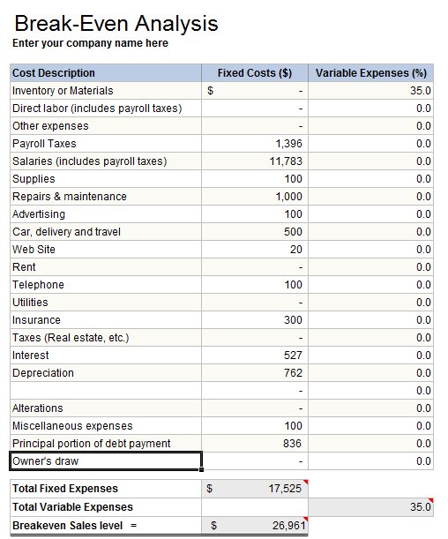

Projected Monthly Income
Projecting income for the food truck business could take many forms. I tried to find out as much as I could about the industry and the local competitors. I checked with local vendors as to amount of food purchases others made. Another useful piece of information indicated that if you estimate the number of people within walking distance of the truck's location during lunch time is a good starting place to estimated projected sales. At first I looked at population in the waterfront area. However, tourists are the main target market. To project how many tourists were in the waterfront area, I used Trivago. I set the search criteria for 1/2 mile from a popular beach located near the wharf, and the harbor. Twenty three hotels matched the criteria. I then checked each hotels website to determine the total number of rooms available at each hotel. I came up with 1,296 rooms. Most of the hotels down by the beach are always occupied. If one assumes 2.5 persons on an average in each room, you will come up with 3,240 people staying at the 23 beachfront hotels. If 50% of them buy lunch then we have 11,620 possible customers. If only 7% of those actually buy lunch at your food truck, you will come up with 113 customers. If each customer purchased an average meal - $12.40 (1 drink, 1 side and one slider). That comes to $1,406 per day. If we operate the truck 22 days a month that equals $30,935 sales in a month. Now let's plug all of these numbers from the breakeven analysis and the cost of goods sold and the projected revenue into our income statement. Other things to consider are special events, parades, and special events like volleyball tournaments, craft shows. Fiesta is in August and goes all week. Thousands attend this yearly event. Santa Barbara harbor is a port of call for Princess Cruise Lines. There 10 scheduled for 2017. Two each month.
The list below shows Transient Occupancy Taxes collected for last year. Our bed tax rate or TOT is 12% of all room revenues.

- January: 1.2 million dollars
- February: 1.2 million dollars
- March: 1.4 million dollars
- April: 1.4 million dollars
- May: 1.5 million dollars
- June: 1.8 million dollars
- July: 2.2 million dollars
- August: 2.3 million dollars
- September: 1.8 million dollars
- October: 1.6 million dollars
- November: 1.5 million dollars
- December: 1.3 million dollars

We also project to cater at least two events per month producing 2,884.23 dollars. That is a package 3 for 2 hours and twenty guests plus a package 2 for 30 guests for 2 hours

Inside Slider Food Truck and Catering Company
Income Statement
For the period ending Current Date
REVENUE
Sales $30,935
Catering Income $2,884.23
Total Revenue $33,819.23
COST OF MERCHANDISE SOLD
Beginning Inventory
Purchases
Total cost of merchandise available for sale
Less: Ending Inventory
Cost of Goods Sold $11,836.73
Gross Profit $21,982.50
EXPENSES
Salary Expense $11,783.00
Repairs Expense $1,000.00
Advertising Expense $100.00
Fuel Expense $500.00
Depreciation Expense $762.49
Insurance Expense $300.00
Miscellaneous Expense $100.00
Payroll Taxes Expense $1,396.33
Legal And Accounting 00.00
Utilities Expense $100.00
Web Internet Expenses $20.00
Interest Expense $526.75
Propane Expense $100.00
Total Expenses $16,688.57
Net Profit $5,292.93

Projecting Yearly Income
A spreadsheet is a great tool for projecting income and expenses when starting up a business. We will make projections for a year. Here is our 6 month projection. You will note that we hope to keep expenses constant and increase our food truck sales by 2% each month. The projections will include cruise ship revenue, and Old Spanish Day's Fiesta. The amount of interest on the loan will change each month slightly. See the amortization schedule for amounts.

InsideSliderProjections.xls
To summarize the 6-month projections shown in the spreadsheet
January – June Sales Projections
- Sales $208,981.21
- Catering Sales $17,305.38
- Total Sales $226,286.65
- Cost of Goods Sold $79,200.00
- Gross Profit $147,086.32
- Net Profit $47,033.55

Financial Write-Up

The balance sheet reflects the current assets and liabilities of Inside Slider Food Truck and Catering Company. The truck was the biggest asset costing $85,000. It came fully equipped and it was brand new. The owner invested $10,000 which went for the purpose of purchasing common stock in the S-corporation that was formed. The liability, the note payable, reflects the loan which consists of cost of the truck, uniforms, cooking utensils, fixtures and inventory. The loan was negotiated at 7% for 7 years.

A projected income statement was drawn up reflecting average costs for food truck operations. Payroll was one large expenditure. It includes salaries for 160 hours/month or 40 hour work week. The CEO is the truck manager and will receive $65,000 per year. The caterer/chef gets $38,400. The window person, receives $20,000 and the kitchen worker, $18,400. Based on research, these are competitive salaries. Cost of goods sold is based on 35%. Much research was done to determine the cost and price of each menu item. Also Biz-stats website was checked for similar operations for the indicated cost of good s sold. One thousand dollars was allocated for repairs since keeping all equipment is critical to our operation. Payroll taxes were calculated using current tax brackets. State payroll taxes were for California, where the truck is based. Interest on the loan was included. A Break-Even analysis was prepared using these expenses along with the cost of goods sold to determine the break- even point. Revenue was determined by room occupancy of hotels within a half a mile of our daily truck locations. Projections were done on income for 6 months looking at a 2% increase each month in revenue while keeping expenses constant.
Start-up Budget

We have $10,000 in cash and we need to purchase some things before we begin operations. The propane tank needs to be filled, along with gasoline for the generator and truck. The insurance policy need to be purchased, permits and licenses need to be obtained. Point of sale equipment, phones and credit card reader need to be acquired.

- Propane tanks fill ups: $50.00
- Fuel for truck and generator $100.00
- Purchase pots, pans and utensils, $1,500.00
- Purchase beginning inventory, $1,500.00
- Purchase paper goods, $250.00
- Fire extinguisher, $150.00
- Permits and licenses, $300.00
- Point of sale equipment $300.00
- Pay first month's insurance premiums $300.00
The total amounts to $4,450.00, leaving $5,550 cash

Strengths, Weaknesses, Opportunities, Threats

Strengths
- Mobility is a great strength, You can move your truck to many diffrent locations
- Reduced expenses such as rent, dish washing, waiters
- New trendy idea

Weaknesses
- Fighting concept of inferior food
- Limited space to work in
- Special permits needed for events, etc.
- Seasonal: more business during warmer months
- Limited menu options

Opportunities
- Develop new markets: funk zone: supply food to craft brewerers during lunch and happy hours
- Ability to easily expand by getting an additional truck

Threats
- It is quite easy for competitors to enter into the field since you can get in with a minimal investment.

Appendix

